Manual to use scripts for calculation of apparent horizontal anisotropy from radar spectrograms

**1.- Script „beat_analysis_DoubleFilter.m“**

The script preprocesses the radar data and calculates the power spectrogram. The files to be worked on are listed in an ASCII file *.txt:

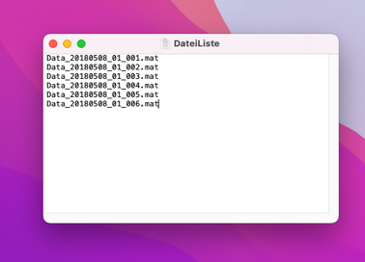

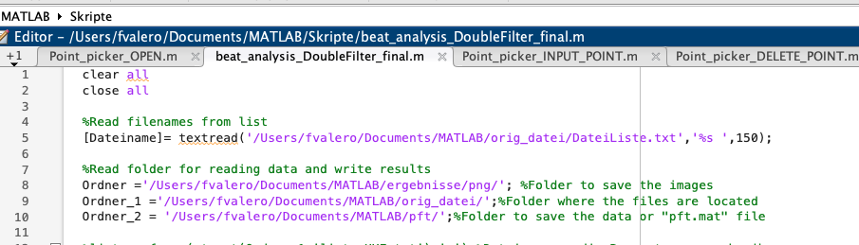

The files listed in the .txt are sequentially called and analysed. For all files, a joint

Region of Interest (ROI) in the vertical domain (travel time given in samples) has to be chosen such as to avoid artifacts from the surface, multiples or the reflection from the ice base. This will be done in two subsequent pop-up windows:

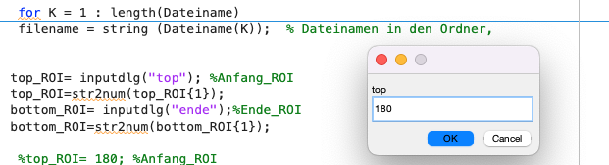 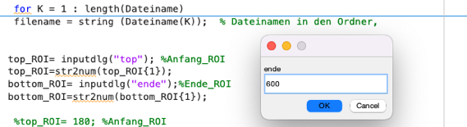

A bandpass filter, characteristics of which are predefined in the script, is applied twice, first to the original radargram, second to the file with the cut-out ROI:

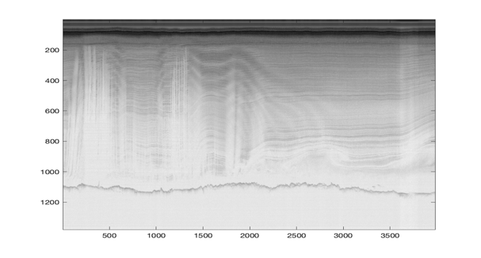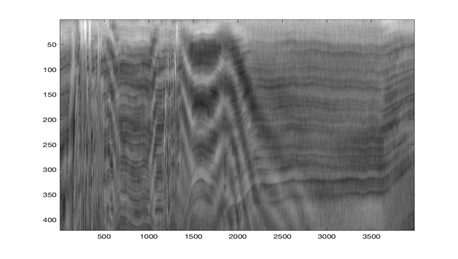

The spectrogram is then calculated from the filtered radargram using the function *pspectrum*. All traces are concatenated to form a single time series and the fast-fourier transform applied to this time series. The spectrogram is calculated along a moving window as defined in *pspectrum*.

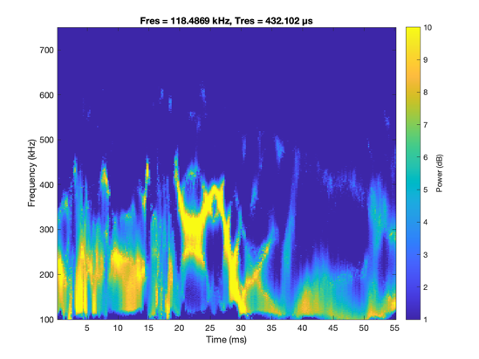

The variables of the calculated spectrogram will be stored in the file, using the original file name and adding the tail „ptf.mat“ (ptf: power-time-frequency). E.g., from the original file „Data_20180508_06_002.mat“ the file „Data_20180508_06_002_pft.mat“ will be created. The files will be stored in the folder given in the scripts. The time along the time series then corresponds to the distance (i.e. trace number) of the original radargram.

**2. Script „beat_analysis_pft.m“**

The script analyses the spectrogram and semi-manually determines the dominant modes of the beat frequency. The script uses the file „*ptf.mat“ created in step 1.

Two variables have to be defined:

a.- cut-off value for the power spectrum (variable „sw“): The frequencies of the spectrogram (colour coded in above figure) are displayed in „power scale [dB]“ in the Interval [0 10]. Power of frequencies not exceeding the cut-off value will be muted Frequenzen. We tested various values and had most reasonable results with sw (3, 5, 8). For our main case, the NEGIS data set (Gerber et al, 2023) we use the cut-off value (Schwellwert) of 8.

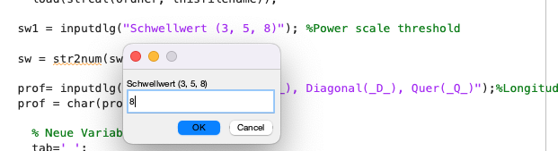

b.- Pre-selection of profiles: the survey is divided in three categories for easier interpretation and display: longitudinal/along-flow (L), diagonal (D) and across-flow (Q). This flag is added to the file name and has no further influence on the data.

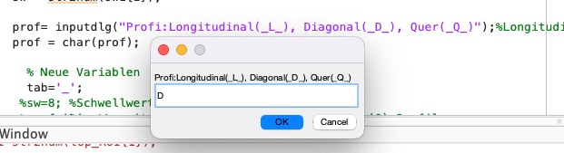

The figure shows the muted spectrogram in the bottom panel.

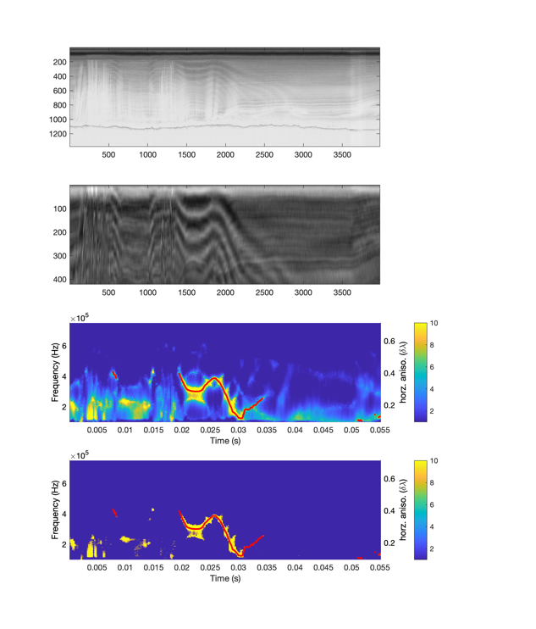

A mean value is calculated between the maximum and minimum value of the spectrogram and the corresponding beat frequency automatically assigned for each time (i.e. equivalent to trace number). The frequency is converted to the horizontal anisotropy Delta lambda (in our case for the AWI UWB MCORDS5 radar the conversion factor is 9.5 * 10-7, see Gerber et al. (2023) for details).

The results, i.e. the dominating mode for each frequency, will be stored in a new file, e.g. Data_20180508_06_002_pft_qc_.mat

**3.- Manual quality check (qc) and correction with scripts:**

**Point_picker_OPEN.m,**

**Point_picker_OPEN_V.m,**

**Point_picker_INPUT_POINT.m,**

**Point_picker_DELETE_POINT.m,**

**Point_picker_SAVE_WORKSPACE.m**

The automatically determined dominating mode of the beat frequency in step 2 is at times faulty and has to be manually checked and partly corrected.

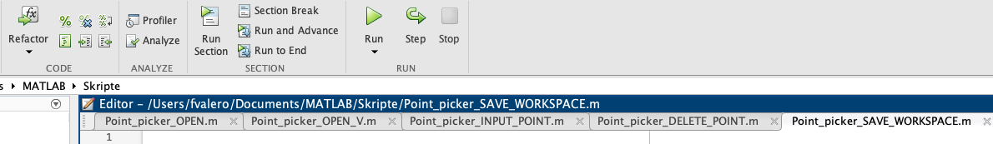

The script Point_picker_OPEN.m opens the file „_pft_qc_.mat“

With the script „Point_picker_INPUT_POINT.m“ and „Point_picker_DELETE_POINT.m“ points of the automatically determined beat frequency can be added and removed, respectively.

The script „Point_picker_SAVE_WORKSPACE.m” saves the corrected values.

For this post-processing stept the file “_pft_qc_.mat“ has to be opened with the script ”Point_picker_OPEN_V.m” otherwise the corrected points in the workspace will be lost and the original values displayed.

